PHOTO | 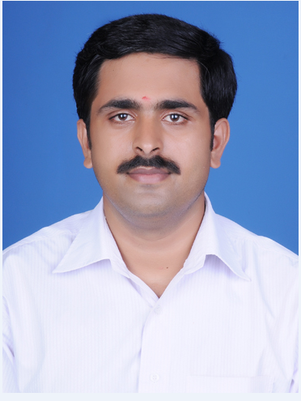
Name | ABHILASH KRISHNAN TK
Designation | ASSISTANT PROFESOR
Email | abhilashkrishnantk@sngcet.org
Mobile | 9400705315
Landline | 04672205315
Specialization | ELECTRICAL AND ELECTRONICS ENGINEERING
Date of Joining | 13/9/2010

EDUCATION
DEGREE | UNIVERSITY | YEAR | SPECIALIZATION
M.TECH | VTU. BELGAUM, | 2010 | Electrical Power System
B.TECH | VTU. BELGAUM, | 2006 | ELECTRICAL & ELECTRONICS

EXPERIENCE
YEAR FROM | YEAR TO | ORGANIZATION | DESIGNATION
2006 | 2007 | C T RAMANATHAN &Co | SITE ENGINEER
2008 | 2010 | SJMIT.CHITRADURGHA | LECTURER
2010 | To till date | SREE NARAYANA GURU COLLEGE OF ENGINEERING AND TECHNOLOGY.PAYYANUR | ASSISTANT PROFESSOR

CONFERENCE AND JOURNAL PUBLICATIONS
Sl.No | NAME
1 | “Zigbee Based Power Monitoring System” National Conference On Power and Energy Systems, july 2010.

SUBJECTS HANDLED
Sl.No | NAME
1 | Electrical Machines.
2 | Control system-II
3 | Digital Electronics &Logic Design
4 | Power System,
5 | Electrical System design and Estimation
6 | Power system generation transmission and protection
7 | New and Renewable Energy Sources
8 | Material science
9 | Introduction to Electrical Engineering
10 | Electrical Machine Design
11 | Electrical System Design
12 | Electrical Drives and Control for Automation
13 | Biomedical Instrumentation
14 | Measurements and Instrumentation
15 | Data Base Management Systems
16 | Energy Management and Auditing
17 | Basic Electrical Engineering
18 | Synchronous and Induction Machines

FDP/STTP
Sl.No | NAME
1 | FDP on “ NBA Accreditation procedures “ Organised by National institute of Technical Teachers Training &Research at SNGCET on SNGCET on 17th to 22nd December 2018
2 | One Day Workshop on R programming Language For Teachers at VJCE,chemberi on 9th November 2019
3 | STTP on Simulation of Power Electronics and Power System using MATLAB,ANSYS,and MIPOWER ,organised by Dept of EEE,GCE.Kannur from 25/7/2016 to 29/7/2016
4 | FDP on Industry 4.0 – Technological Advances and implications Sponsored by KTU, 17th - 21st JUNE 2019 at Adi Shankara Institute of Engg&Tech,kalady.
5 | Workshop on “Industrial Automation & Introduction to IOT” at SNGCET in November 2019
6 | FDP on “Teaching Learning Process” at SNGCET in December 2019

Achievements / Contributions
Sl.No | NAME
1 | Deputy Chief Supridentent of Kannur University Examinations
2 | Convenor of College Grievances and Appeal Committee
3 | Coordinated one Day workshop on “Industrial Automation &Introduction to IoT “ November 2019
 | Coordinated one Day workshop on “Energy Management and Auditing” September 2018
4 | In charge of Department Time Table coordinator
5 | In charge of Department NBA coordinator
6 | Convenor of Internal Quality and Audit Committee

