Education

Degree | University | Year | Specialization
M-Tech | VTU | 2015 | Computer Science and Engineering
B-Tech | Kannur | 2007 | Computer Science and Engineering

Experience

Year from | Year to | Organisation | Designation
2007 | 2008 | Karuna computer education, payyanur | Software faculty
2008 | 2009 | Govt. Residential Polytechnic, Payyanur. | Guest lecturer
2011 | 2013 | Chinmaya Vidyalaya, Payyanur. | Teacher
2015 | 2016 | Ursuline Senior Secondary School | Teacher
2016 | 2017 | Govt. Residential Polytechnic, Payyanur. | Guest lecturer
2017 | 2018 | Govt. Residential Polytechnic, Kasaragod. | Guest lecturer

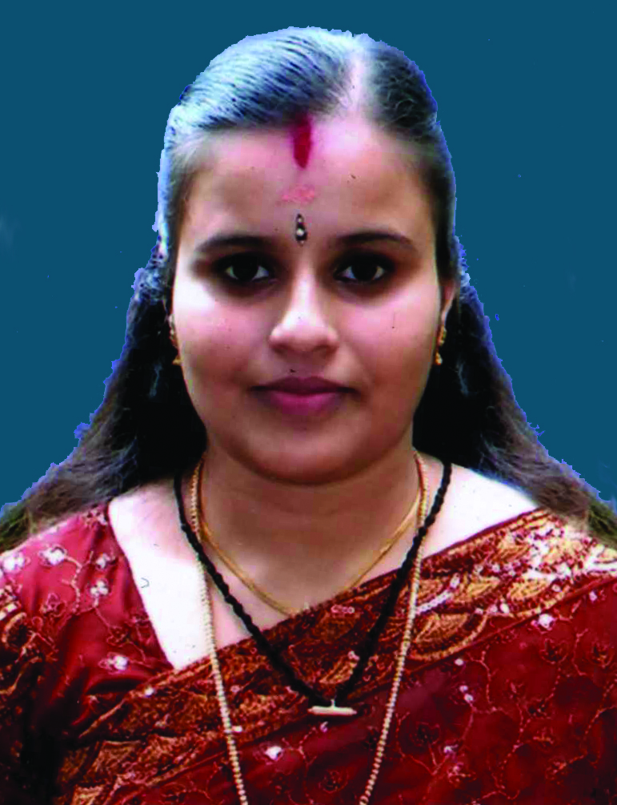

Mrs. Varsha.M
varsham@sngcet.org
Assistant Professor

