Education

Degree | University | Year | Specialization
M-Tech | A P J Abdul Kalam Technological University | 2019 | Computer Science and Engineering
B-Tech | Kannur | 2013 | Computer Science and Engineering

Experience

Year from | Year to | Organisation | Designation
2019 | 2021 | NMIT, Kanhangad | Assistant Professor

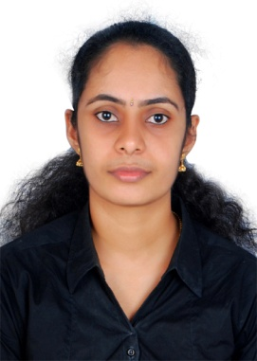

Ms. Nimisha.M.K
nimishamk@sngcet.org
Assistant Professor

