Education

Degree | University | Year | Specialization
M-Tech | A P J Abdul Kalam Technological University | 2021 | Computer Science and Engineering
B-Tech | CUSAT | 2018 | Computer Science and Engineering

Experience

Year from | Year to | Organisation | Designation
2019 | Present | Sree Narayana Guru College of Engineering & Technology, Payyanur | Assistant Professor

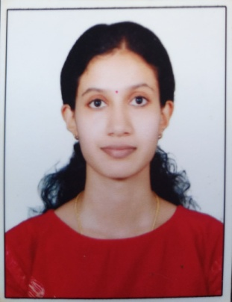

Ms. Vijina Vijayan
vijinavijayan@sngcet.org
Assistant Professor

