PHOTO | 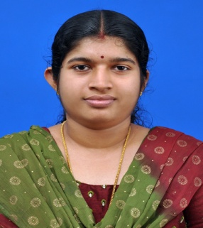
Name | Mrs. BINDIYA M C
Designation | ASSISTANT PROFESOR
Email | bindiyamc@sngcet.org
Mobile | 9495344308
Landline
Specialization | PHYSICS
Date of Joining | 23/09/2015

EDUCATION
DEGREE | UNIVERSITY | YEAR | SPECIALIZATION
B.Sc | KANNUR UNIVERSITY | 2000 | PHYSICS
M.Sc | KANNUR UNIVERSITY | 2002 | PHYSICS
B.Ed | CALICUT UNIVERSITY | 2004 | PHYSICAL SCIENCE

EXPERIENCE
YEAR FROM | YEAR TO | ORGANIZATION | DESIGNATION
2002 | 2003 | S N VIDYA MANDIR.KANNUR | PRT
2011 | 2012 | St. FRANCIS ENGLISH MEDIUM SCHOOL,THOTTADA | TGT
2012 | 2015 | KASTURBA PUBLIC SCHOOL, KANNUR | PRT
2015 | PRESENT | SREE NARAYANA GURU COLLEGE OF ENGINEERING AND TECHNOLOGY .PAYYANNUR | ASSISTANT PROFESSOR

SUBJECTS HANDLED
Sl.No | NAME
1 | ENGINEERING PHYSICS

FDP/STTP
Sl.No | NAME
1 | FDP on ”Teaching learning Process” from SNGCET 2019
2 | FDP on “NBA Accredation Process” from SNGCET 2018

Achievements / Contributions
Sl.No | NAME
1 | In charge of Department Internal Exam Coordinator
2 | In charge of Department NBA Coordinator

