Degree | University | Year | Specialization
M-Tech | VTU | 2016 | Digital Electronics and Communication Systems
B-Tech | Kannur | 2014 | Electronics and Communication Engineering

Education

Experience

Year from | Year to | Organisation | Designation
2016 | 2017 | E K N M Government ITI, Kayyur | Junior Instructor
2017 | 2019 | NMIT,Kanhangad | Assistant Professor
2019 | Present | Sree Narayana Guru College of Engineering, Payyanur | Assistant Professor

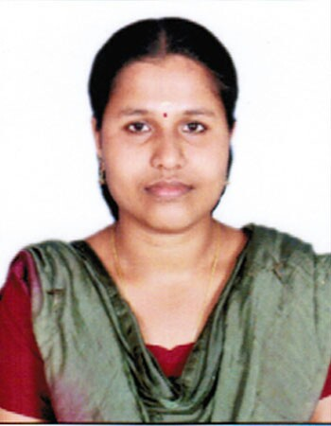
Mrs. Meera M
meeram@sngcet.org
Assistant Professor
Degree | University | Year | Specialization

