Education

Degree | University | Year | Specialization
M-Tech | A P J Abdul Kalam Technological University | 2020 | Computer Science and Engineering
B-Tech | Kannur | 2007 | Computer Science and Engineering

Experience

Year from | Year to | Organisation | Designation
2020 | 2022 | Sadguru Swami Nithyananda Institute of Technology, Kanhangad | Assistant Professor

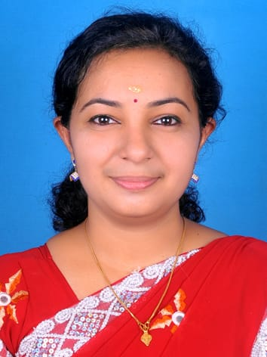

Mrs. Thulasibai.A
thulasibai@sngcet.org
Assistant Professor

