PHOTO | 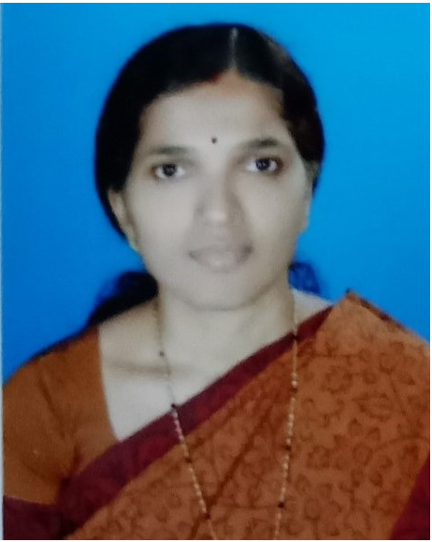
Name | Mrs.SARITHA SASINDRAN
Designation | ASSISTANT PROFESOR
Email | sarithasasindran@sngcet.org
Mobile | 8301918207
Landline | 04672261206
Specialization | COMPUTER AIDED STRUCTURAL ENGINEERING
Date of Joining | OCTOBER 2015

EDUCATION
DEGREE | UNIVERSITY | YEAR | SPECIALIZATION
M.TECH | KANNUR UNIVERSITY | 2015 | COMPUTER AIDED STRUCTURAL ENGINEERING
B.TECH | CALICUT UNIVERSITY | 1991 | CVIL ENGINEERING

EXPERIENCE
YEAR FROM | YEAR TO | ORGANIZATION | DESIGNATION
1991 | 1995 | DEPARTMENT OF POSTS INDIA | POSTAL ASSISTANT
1996 | 2012 | DESIGN CONSULTANCIES IN UAE | STRUCTURAL DESIGN ENGINEER
2012 | 2013 | COLLEDE OF ENGINEERING THRIKARIPUR,  CHEEMENI | ASSISTANT PROFESSOR
2015 | TILL DATE | SREE NARAYANA GURU COLLEGE OF ENGINEERING AND TECHNOLOGY .PAYYANNUR | ASSISTANT PROFESSOR

CONFERENCE AND JOURNAL PUBLICATIONS

Sl.No | NAME
1 | “Experimental Study on Concrete by Partially Replacing Cement with Calcium Bentonite and Fine Aggregate with Steel Slag’ - May 2018 International Organization of Scientific Research(IOSR) , Journal of Engineering.
2 | ‘Analytical Study on Thermal Behaviour of RC Beams Retrofitted with Rubberised Concrete and GFRP using Ancys Workbench’ - Volume 4, Issue 2, 2019, International Research Journal of Advanced Engineering and Science.
3 | ‘ Performance based Seismic Analysis of a Reinforced Concrete Building’ -NACTAE-2015 Sree Narayana Guru College of Engineering and Technology, Payyanur
4 | ‘Vibration Control Measures for Offshore Jacket Structures‘ -NACTAE-2016 Sree Narayana Guru College of Engineering and Technology, Payyanur
5 | ‘Effect of Sea Water on Mixing and Curing of Concrete’ - NACTAE-2016 Sree Narayana Guru College of Engineering and Technology, Payyanur
6 | ‘Application of Extended N2 Method on Regular and Irregular Structures’ NACTAE-2016 Sree Narayana Guru College of Engineering and Technology, Payyanur
7 | ‘Performance of Polypropylene Fiber Reinforced Concrete’ NACTAE-2018 Sree Narayana Guru College of Engineering and Technology, Payyanur

SUBJECTS HANDLED
Sl.No | NAME
1 | Design of Concrete Structures
2 | Design of Steel Structures
3 | Design of Hydraulic Structures
4 | Irrigation Engineering
5 | Architecture , Housing and Planning
6 | Pre Stressed Concrete Structures
7 | Quantity Surveying and Valuation
8 | Basic Civil Engineering
9 | Finite Element Method
10 | Design of Bridges

FDP/STTP
Sl.No | NAME
1 | Workshop on ‘Advances in Bridge Engineering’ 18/01/2017 to 20/01/2017 at Govt. College of Engineering Kannur
2 | Hands on Workshop in STAAD and ETABS 26/06/2017 to 30/06/2017 at Govt. Collegeof Engineering Kannur , sponsored by DTE - Kerala
3 | FDP on “NBA Accredation Process” from SNGCET 2018
4 | FDP on ”Teaching learning Process” from SNGCET 2019

Achievements / Contributions
Sl.No | NAME
1 | In charge of Department Placement Coordinator
2 | In Charge of Class Advisor

